Unix shell command

Shell scripts end with .Sh extension.

Once written the permission needs to be changed to 777 using chmod command. Then executed with ./filename.sh.

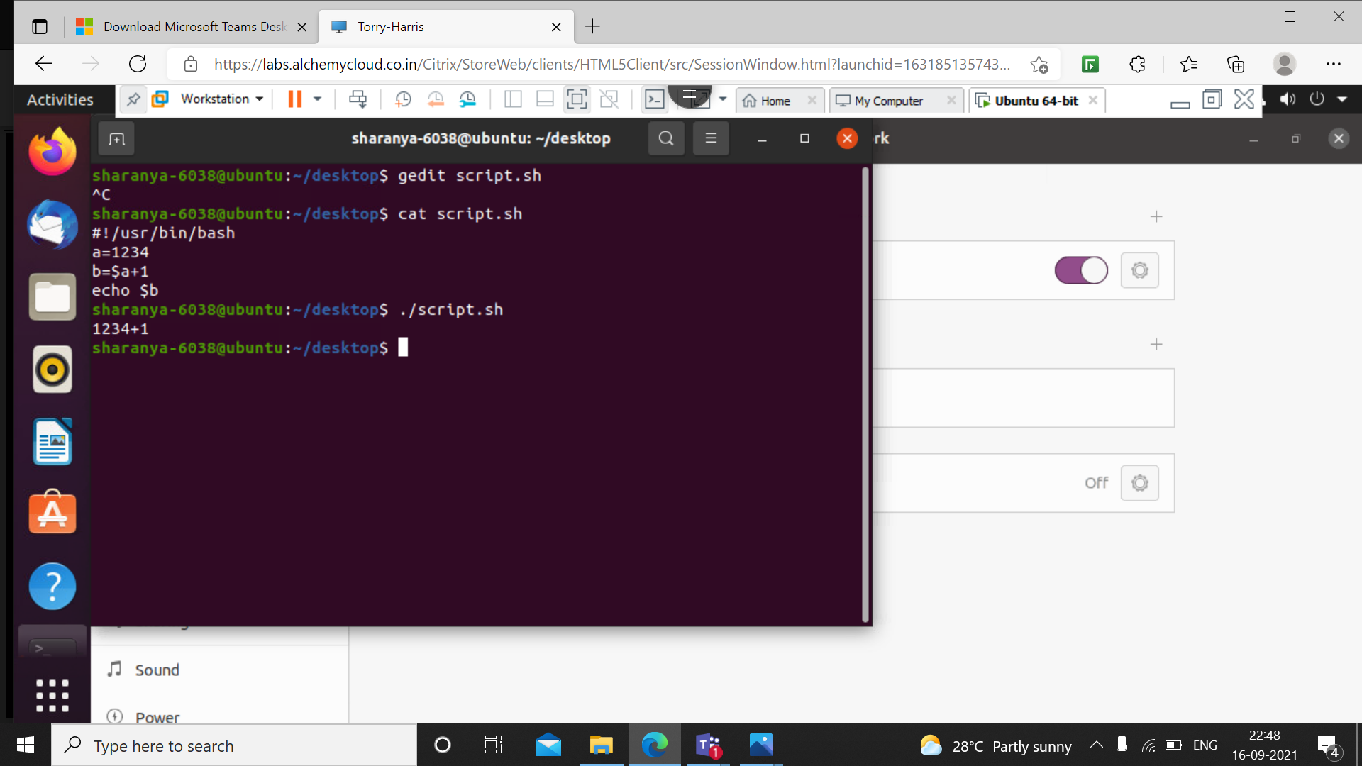

Use of expr converts string into integer and performs addition operation.

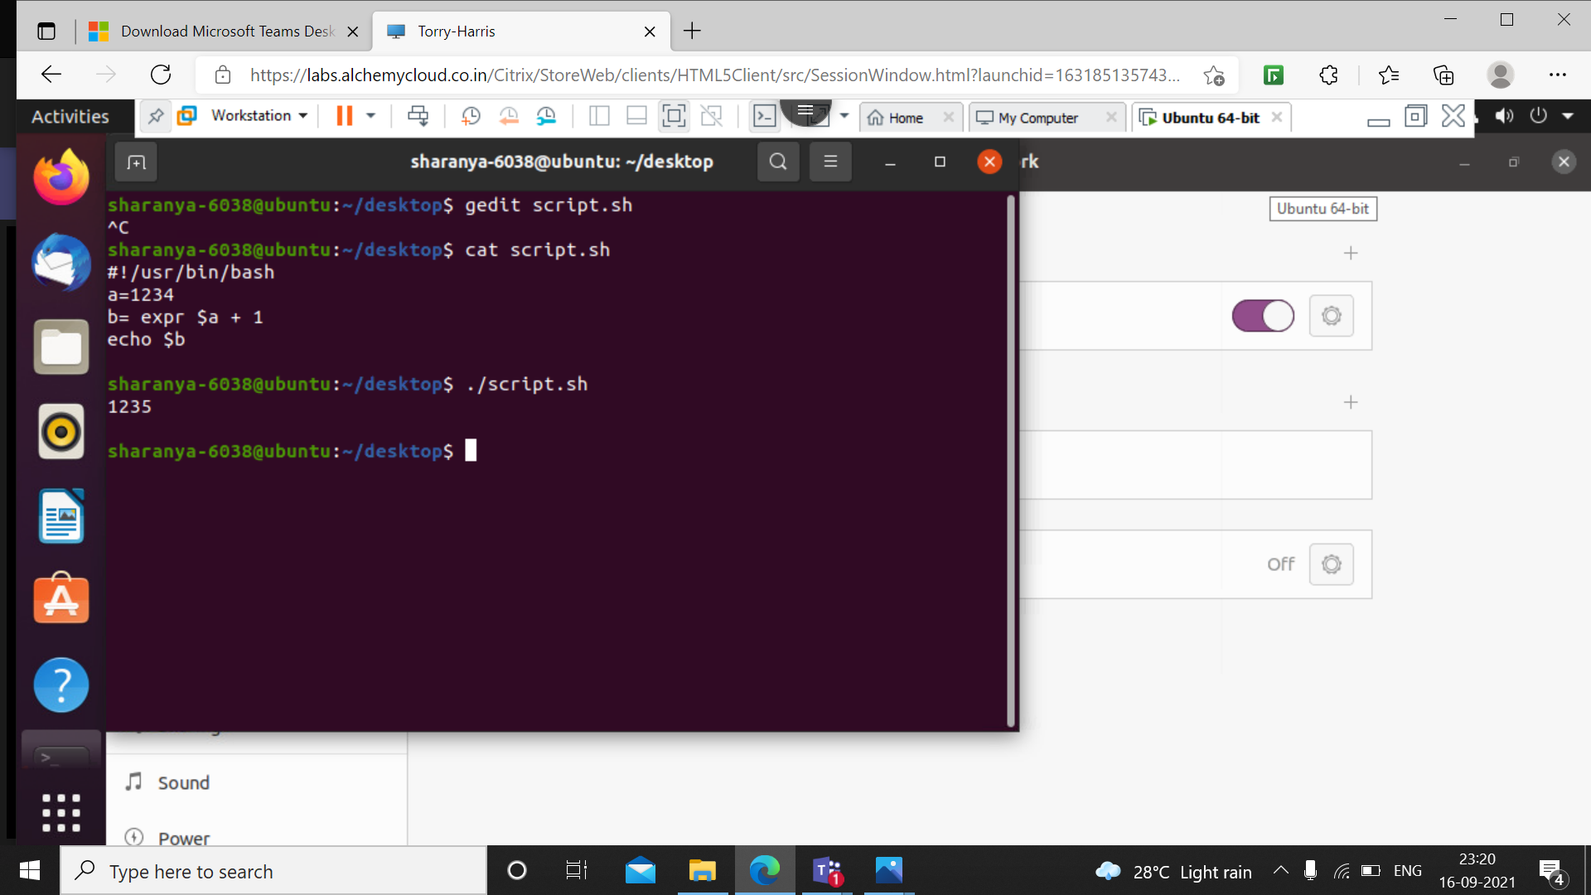

Giving command line arguments

In the below shell script, $# represents the number of command line arguments, the positional parameters representing the command line arguments begin with $1, $2 and so on.

Here $1 is the first argument 33 and $3 third 456.

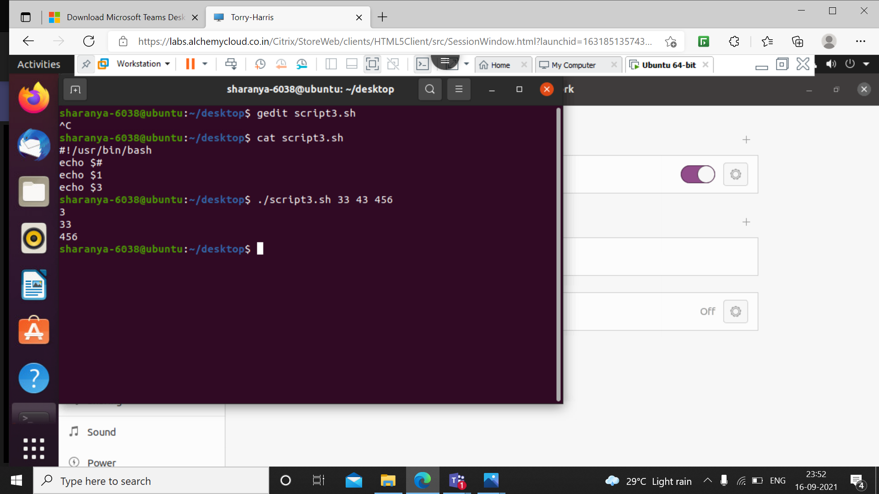

Displaying an array and individual elements of an array

An array is represented using $ symbol outside of array name with its respective index, and \* to display entire array.

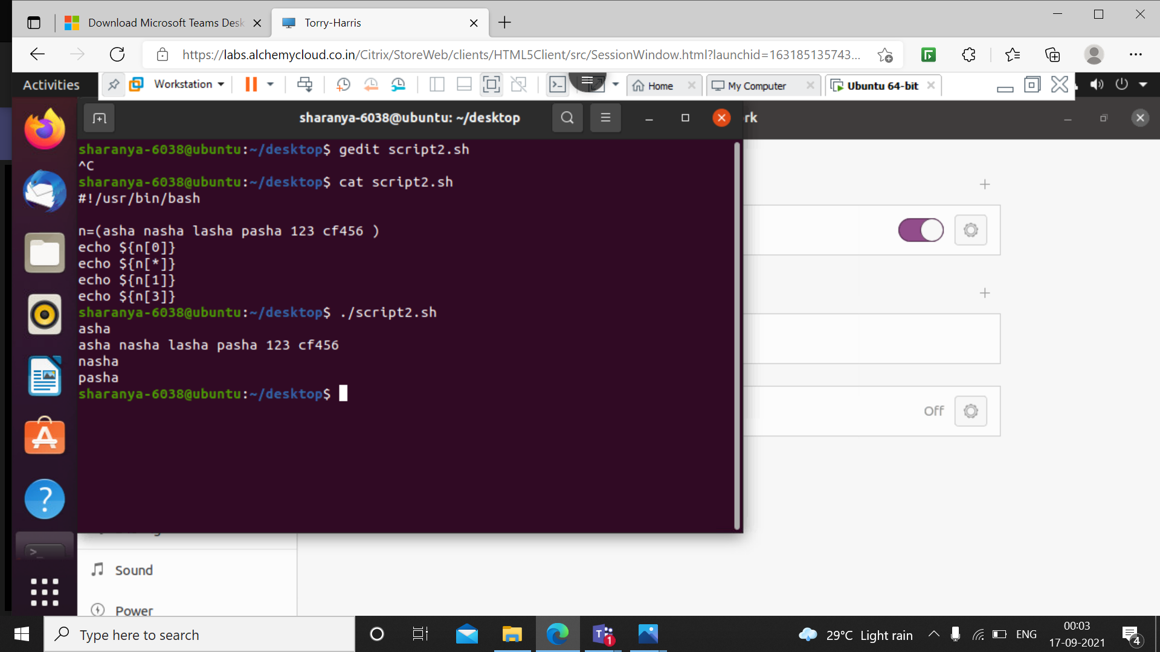

Use of if else loop

The syntax follows like any other programming language.

The comparison operator is either ‘==’ or ‘–eq'.

The below script shows the comparison using command line argument.

‘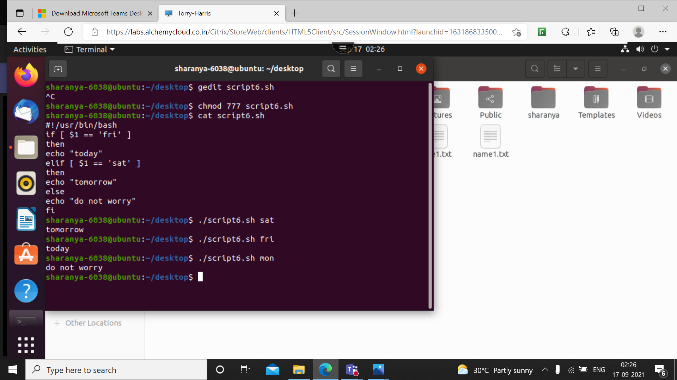

If else loop for comparing two values using –eq operator.

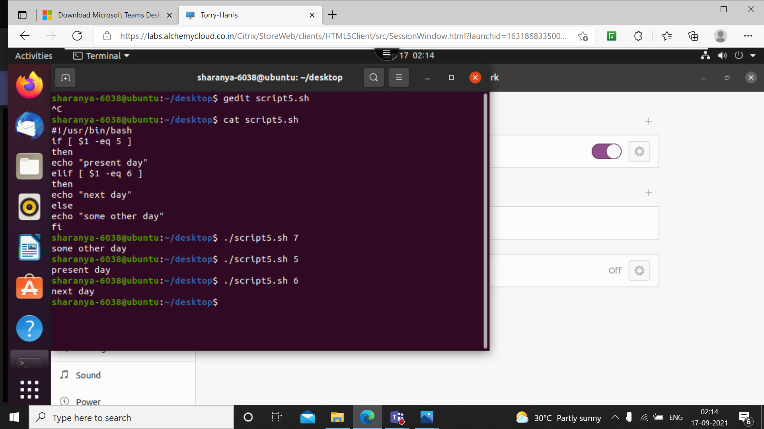

For loop

The syntax for for loop is for[arg] in [list]

Do

Command

Done

The following shell script shows an if loop inside for.

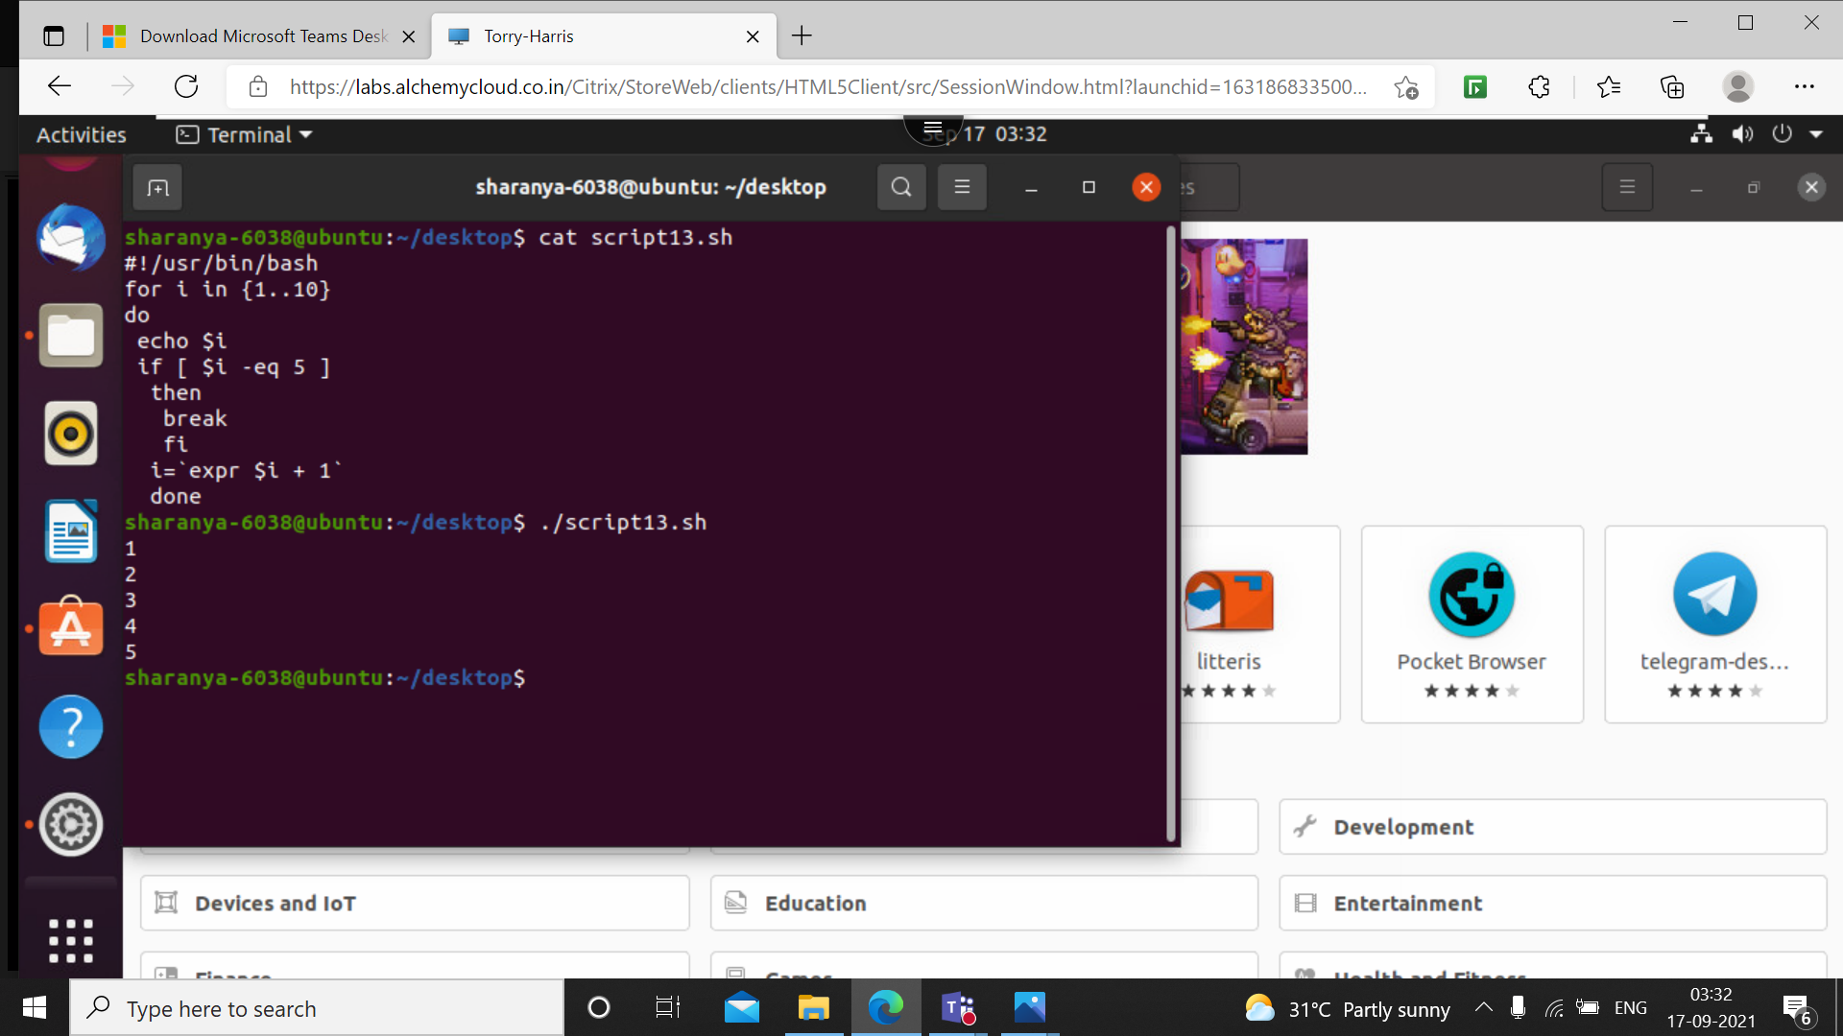

The following for loop has the syntax of for loop in any other programming language.

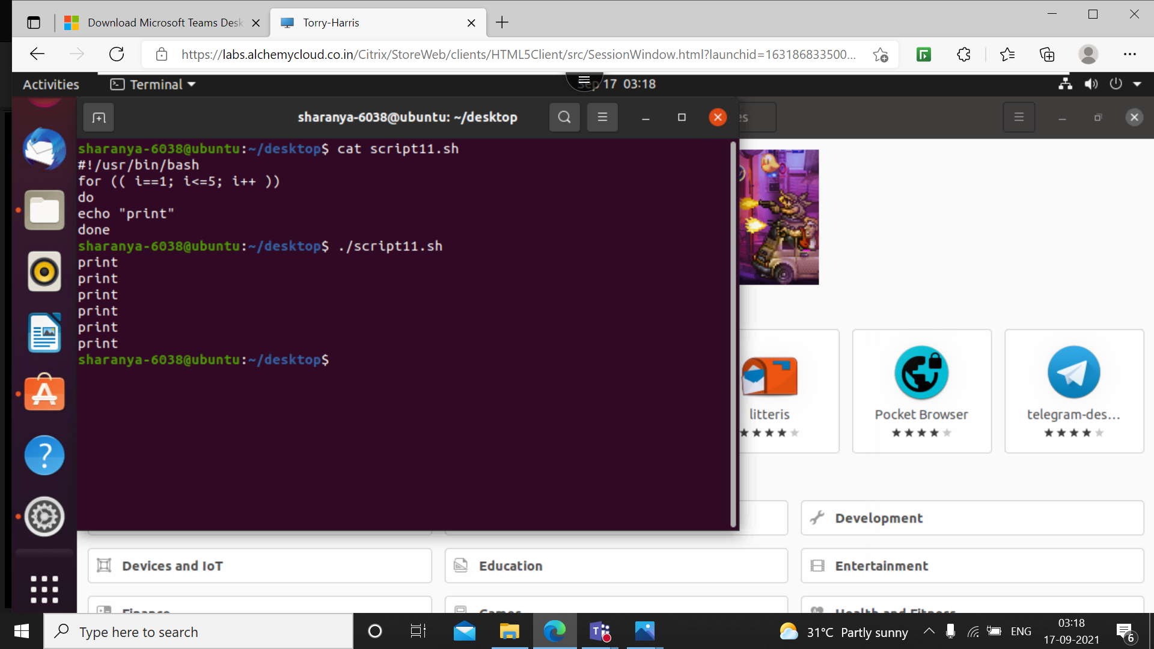

The following shell script uses for loop to display numbers with common deference between them.

Here 10 is the initial condition, 0 is the final and 2 is the common deference.

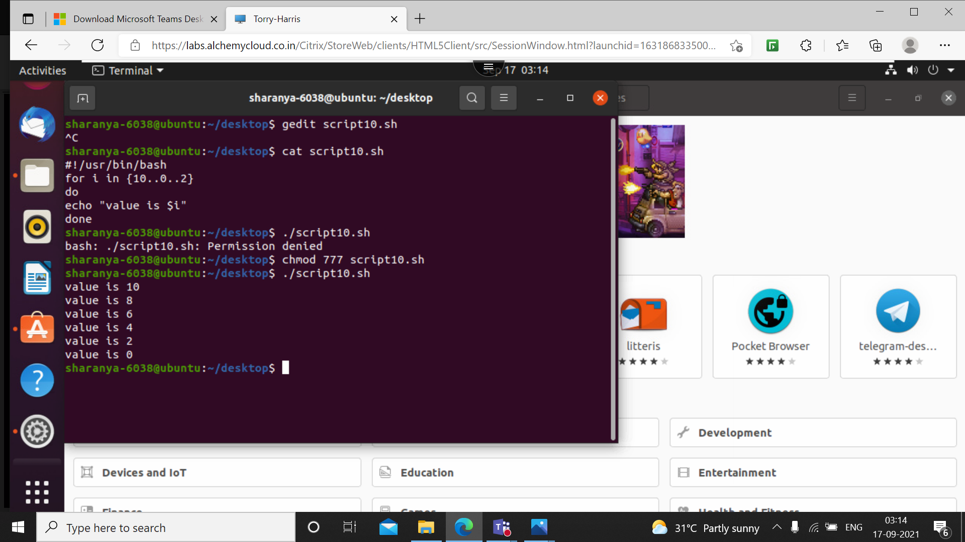

While loop

Has the syntax as while [Cond];

Do

Command

Done

The while loop prints while untill $I is less than 10.

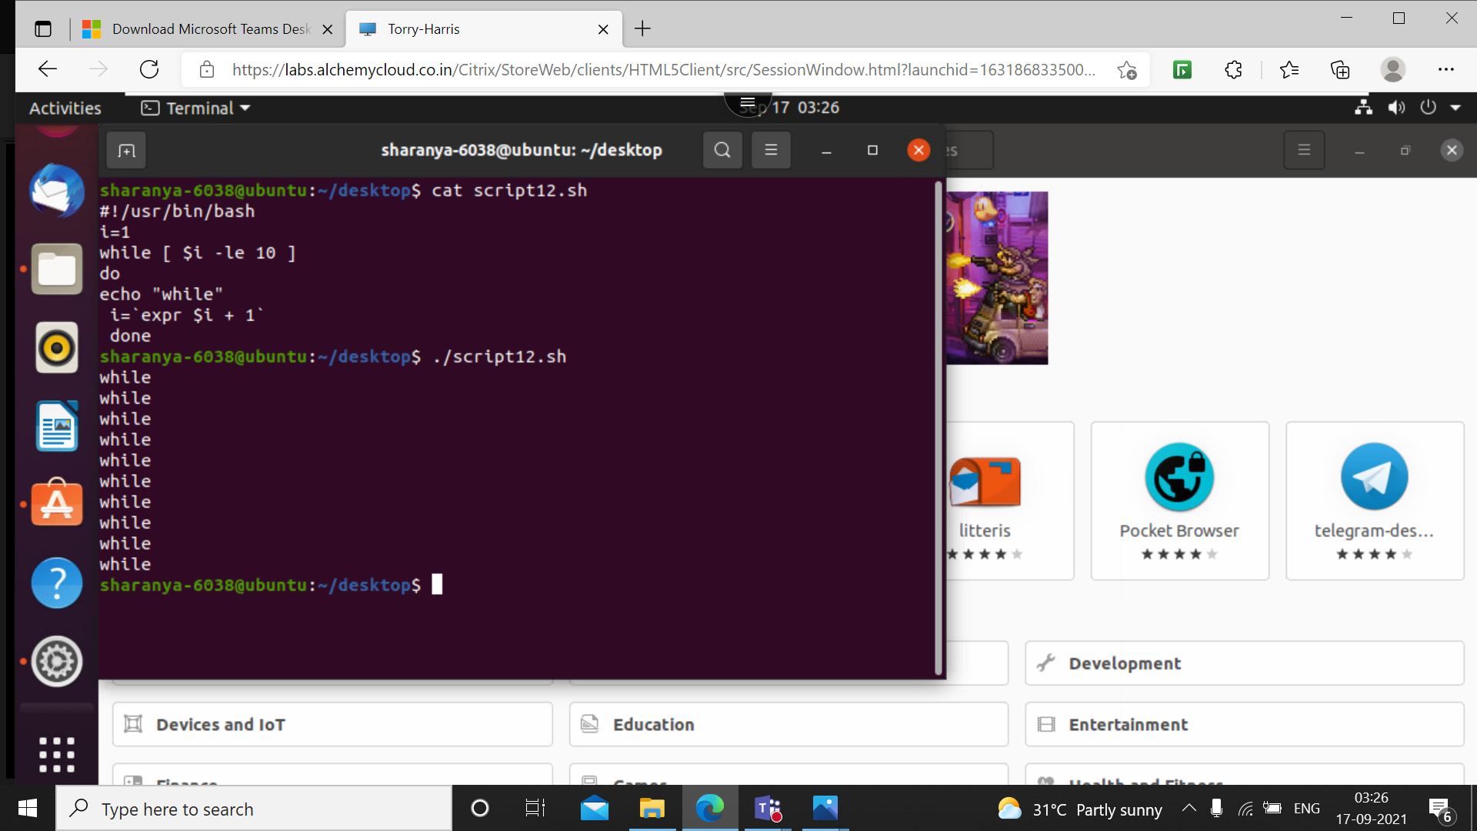

Creating function

Here function test is created named test. when outside the function is called it prints the output of the cujtuonfunction.

